Date: 13th September 2022

Dear Parents/Carers,

Following the announcement that the funeral of Queen Elizabeth II is to take place on Monday 19th September and that this is to be designated as a Bank Holiday we can confirm that Caedmon College Whitby, Eskdale School and Whitby Sixth Form will be closed to staff and students.

During the extended weekend staff, students and parents/carers will be able to participate in the national mourning and to be part of any events organised both locally and nationally.

Staff and students will therefore return on Tuesday 20th September as normal.

If you require any further information or assistance please do not hesitate to contact the schools.

Yours sincerely,

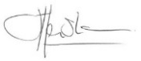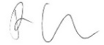

Mr J Henshaw Mr P Nicholson
Executive Headteacher Head of School

